UNIT 9
I . Multiple choice :
- When the teacher came, all class stopped________________. ( to talk/ talking/ talk/ talked)
- Ba feels sick . He ate too _________ candy (many / a lot of / much / any)
- She ‘d like ___________ some fruits for her party . (buy/ to buy/ buying/ bought)
- What about ________________ fishing at the weekend ? (to go / goes/ going/ went)
- Milk is good _________ your health (to /with/ for/ in)
- He __________ his teeth three times a day (brushes / brushed / brush/ brushing)
- I didn’t _______________ an English test last week . (to have/ have/ having/ had)
- The dirt on vegetables can make people __________ (healthy / sick/ well/ good)
- We can see many different types of fish in the ___.( school / museum / aquarium / temple)
- Did you ____________ anything there ? ( buy/ to buy/ buying/ bought)

II. Put the verb in the correct form :
- Nam ( play ) ________________ tennis yesterday.
- We ( visit ) ________________ Dalat two years ago.
- They ( build ) ________________ that house in 1991.
- Nga ( buy ) ________________ some milk in this morning.
- Phong ( write ) ________________ that lesson last week.
- Mrs. Mai ( make ) ________________ Hoa a new dress last Monday.
- They ( go ) ________________ to the zoo yesterday.
- Nam ( watch ) ________________ TV last night.
- I ( not bring ) ________________ that chair into the kitchen in this morning.
- She (decide) ________________ (be) ________________ a famous singer.

III. Read the passage below then check True or False
The Robinsons spent their vacation in Nha Trang last summer. They visited a lot of interesting places in Nha Trang such as : Cham temples , Hon Chong , Tri Nguyen Aquarium … They saw sharks , dolphins, and many types of fish at Tri Nguyen Aquarium . They bought a lot of gifts for their friends in a souvenir shop near the exit of the aquarium . They liked the beach best . They felt happy and healthy after the trip .
- ______The Robinsons didn’t go to Nha Trang last summer.
- ______They visited a lot of interesting places in Nha Trang.
- ______They didn’t buy anything in the aquarium.
- ______They liked the beach very much.
- ______They felt unhappy and tired after the trip.

IV. Word form:
1. English is an...................................and important subject. INTEREST
2. In electronics they learn to repair......................... appliances. HOUSE
3. The most popular............................ at recess is talking. ACT
4. Hoa is having a ............................. check-up. MEDICINE
5. The nurse wanted to know Nga’s height and ................. WEIGH
6. Hoa is the …….......….. student in her school. GOOD
7. I’d like a nice.........................orange. JUICE
8. Edison’s most famous............................was the electronic bulb. INVENT
9. This dictionary is very .................... for you to learn English. USE
10. I have .............. time to play than my friends. LITTLE

V. Rearrangement
1/ is / new school / different / Her / from / old school.
__________________________________________________________________________________
2/ is / Hoa’s sister / reading / interested in / comics / the / on / weekend /
__________________________________________________________________________________
3/ does / go / your / How often / mother / shopping / ?
__________________________________________________________________________________
4/ week / went / family / to / last / my / Vung Tau /
__________________________________________________________________________________
5/ Hoa / her aunt / like / and neither / doesn’t / pork / does / .
__________________________________________________________________________________

UNIT 10
I. Multiple Choice :
1/ Are you scared _______ seeing the dentist ? ( of/ in/ after/ on)
2/ She didn’t ______________ beef for lunch . (eat/ eating/ eats/ to eat)
3/ What is his _____________? – About 45 kilos (high/ long/ far/ weight)
4/ / ____________ will they go to the zoo ? – By car . (What/ How/ When/ Where)
5/ What about ____________ out for dinner ? (to go/ going/ goes/ went)
6/ Minh ___________ to the doctor tomorrow morning (goes/ will go/ going/ to go)
7/ It is a green skirt with white flowers ___________ it . (with/ in/ on/ at)
8/ Would you like ______________ Ha Long Bay ? (going/ goes/ went/ to go)
9/ Did you ________ to Thailand last year ? (to go/ went/ going/ go)
10/ My grandfather __________ trees in the garden at this time . (plant/ to plant/ is planting/ planted)

II. Put the verb in the correct form :
1. We (be) __________________ at the seaside for ten days last summer.
2. She (see) __________________ a movie tonight.
3. Lan (not have) __________________ a health examination last month.
4. She usually (wash and iron) __________________ her clothes every week.
5. Why __________________ you (leave) __________________ the party early last night?
6. Are you scare of (see)__________________ the dentist?
7. I’m glad (hear) __________________ you are well
8. Remember (wash) __________________ your hands before meals.
9. They ( not drink ) __________________ milk yesterday.
10. He ( not be ) __________________ a doctor 3 years ago.

III. Fill in the blanks with given words in the box :
Visited to had at returned was go with postcards
Nam (1)_______________ a wonderful vacation last summer . He (2)_______________ in Hanoi . He stayed (3)______________ his uncle house for three weeks . He (4)_______________ a lot of interesting places: Uncle Ho ‘s Mausoleum, Ba Dinh Square , West Lake….. He bought some (5)_______________ for his friends and a cap (6)_______________ a flag on it . Nam liked the cap very much . When he (7)_______________ to HCM City , he spoke (8)_______________ his friends about his vacation .

IV. Read the passage below then check True or False :
Today , Hoa has a medical check-up . She fills in the medical record and waits in the waiting –room . After a few minutes , the nurse calls Hoa ‘s name and takes Hoa to the doctor’s office. The doctor weighs , measures and takes temperature for Hoa . Everything is normal so Hoa feels very happy .
1/ ______Hoa didn’t have a medical check-up 2/ ______Hoa filled in the medical record.
3/ ______The nurse weighs Hoa 4/______The doctor takes temperature for Hoa
5/ ______Hoa feels unhappy .

V. Rearrangement
1/ are / Most of / scared of / the / seeing / children / dentist. /
__________________________________________________________________________________
2/ should / carefully / our hands / We / wash / meals. / before /
__________________________________________________________________________________
3/ had / vacation / a / last / Nam’s family / a wonderful / last summer. /
__________________________________________________________________________________
4/ hates / the / Nam / of / sound / drill. / the/
__________________________________________________________________________________
5/ this morning. /a / Hoa / medical / had / check-up /
__________________________________________________________________________________

VI. Word form:
  - He is a (help)……..……… person.
  - My tooth is very (pain)………..…… now.
  - Clean teeth are (health)……………… teeth.
  - You should brush your teeth (regular)……….…….
  - We are (worry)……….…… about the final exam.
  - She always washes and irons her clothes (careful)…………
  - I’m (scare)……….…… of hearing the ghost stories.
  - The people here are very (friend)…………

VII. Look at the text in each question. What does it say? Choose the correct letter ( A, B or C)
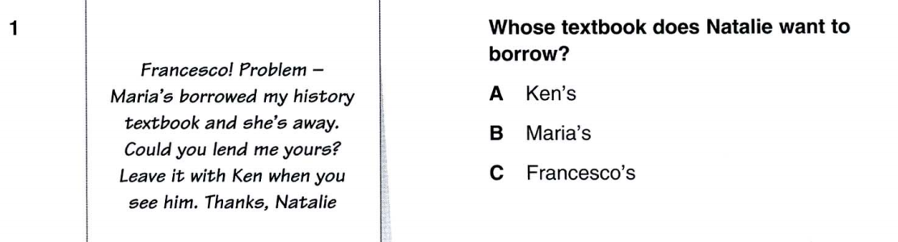
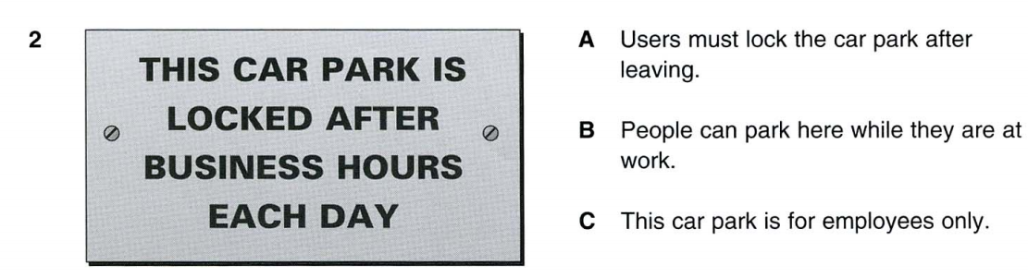
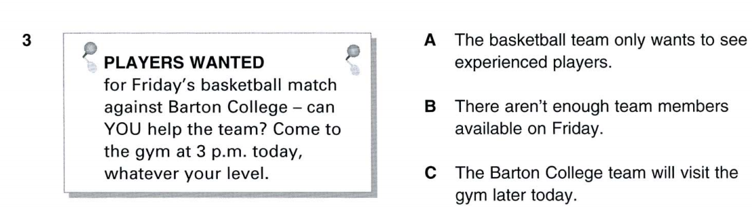
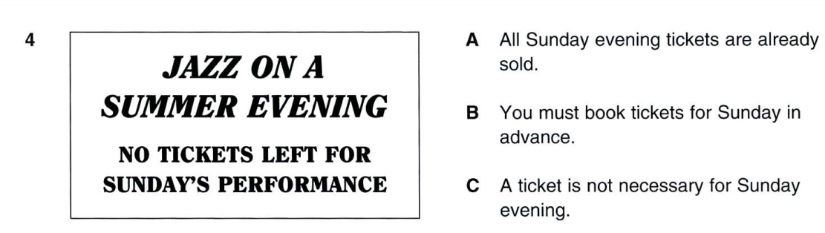
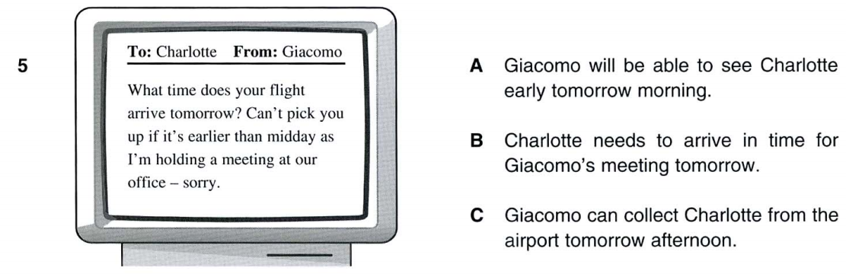

UNIT 11
I/ Choose the word or phrase (A, B, C or D) that best fits the blank space in each sentence:
1. What’s the matter, Lan? I have a (an) _______.
A. appointment B. toothache C. job D. homework
2. Everybody _____ the symptoms of the common cold.
A. know B. knows C. knew D. to know
3. We ought not to eat too much candy because it’s bad _____ us.
A. with B. at C. for D. of
4. The dentist tells them how to look _____ their teeth.
A. for B. at C. after D. in
5. Clean teeth are ______ teeth.
A. kind B. serious C. important D. healthy
6. She smiles _______ her children.
A. in B. with C. to D. at
7. Don’t forget _____ your teeth after meals.
A. brush B. brushing C. to brush D. brush
8. Are you scared of _____ the dentist?
A. seeing B. see C. to see D. saw
9. What are the _____ of the common cold?
A. diseases B. medicines C. symptoms D. book
10. Lan filled in her medical ______.
A. check up B. record C. directory D. book
11. Remember to brush your teeth regularly.
A. Remember to wash your hands regularly. B. Remember to brush your teeth before meals.
c. Don’t forget to brush your teeth regularly. d. Don’t forget to wash your hands after meals.
12. Dr. Lai is checking his teeth.
A. Dr. Lai is examining his teeth. B. Dr. Lai is filling his teeth.
C. Dr. Lai is pull out of his teeth. D. Dr. Lai is taking care of his teeth.
13. When my father visited Dalat, he _______.
A. bought for me a gift. B. bought a gift to me. C. bought a gift me. D. bought me a gift.
14. How tall is she?
A. What is the tall? B. What is the height? C. What is her height? D. What is her tall?
15. Avoid eating a lot of sweets.
A. Don’t eat much cake and candy. B. Sweets are healthy food.
C. You can eat sweets but not much. D. eating much cake is all right.

II/ Fill in the blank with a suitable word form the given words in the box:
Took ears medical height to everything checked happy
Yesterday, Hoa had a (1) ______________ check-up. The nurse weighed her. Then she measured her
(2) ______________. After that she (3) ________________ her temperature. Next, she listened (4) ______________ her heart. Then she (5) _________________ her eyes and (6) ________________. (7) _______________ was normal. Finally, Hoa left and she felt (8) ________________.

III/ Put the verb in the correct form :
- Yesterday, Hoa and her aunt ( go ) ________________ to the market.
- I’d like ( tell ) ________________ you about my father.
- Be careful ! The children ( cross ) ________________ the street.
- My mother ( not watch ) __________________ TV last night, she ( write ) _____________ letters.
- When __________ you ( buy ) ________________ this dress ? – Two days ago.
- I’m glad ( see ) ________________ you again.
- Where Jack ( drink ) ________________ milk in this morning ?
- It ( stop ) ( hurt ) ________________ ________________ last night.

IV/ Rewrite the following sentence without changing meaning:
1. What’s the length of this street?
→ How ___________________________________________________________________________
2. How high is the building?
→ What ___________________________________________________________________________
3. How much does she weigh ?
→ What___________________________________________________________________________
4. How old are you ?
→ What___________________________________________________________________________
5. How deep is Saigon river ?
→ What___________________________________________________________________________
- How tall is Hoa ?
→ What___________________________________________________________________________
7. What’s your weight ?
→ How____________________________________________________________________________
8. What’s his age ?
→ How ___________________________________________________________________________

V/ Read the following passage and answer True (T) or False (F):
Last week, Liz Robinson and her parents went to Nha Trang on vacation. And Mr and Mrs. Robin took Liz to see Tri Nguyen Aquarium in Nha Trang. There are dolphins, turtles and many different types of fish in the aquarium. But Liz thought there are no other fish is more beautiful than the colorful little fish. After they visited the aquarium, they went to a food stall for lunch. Liz’s parents ate fish and crab. When she looked at the fish, Liz remembered the beautiful fish in the aquarium. She ate noodles instead.
1. _______ Aquarium is a place where people can go to see fish and other water animals.
2. _______ Liz thought the colorful little fish is the most beautiful.
4. _______ Liz’s parents like eating seafood.
4. _______ Liz ate pizza instead.

VI. Rearrangement:
1/ relieve/ medicines/The / the /symptoms./
__________________________________________________________________________________
2/ cold? / of / the/ are/the symptoms /common / What/
__________________________________________________________________________________
3/ stay/ should/ inside/ You/ at recess /is/ because the weather/ today/ awful.
__________________________________________________________________________________
4/ I/ bad cold,/ come/ a/ had/so I/ to/ didn’t/ school./
__________________________________________________________________________________
5/ are/ a/The students/ medical/ having/ check- up./
__________________________________________________________________________________

VII. Word form:
- Mrs. Oanh’s daughter is having a _____________check-up. (MEDICINE)
- We need to know your _____________, Minh. (WEIGH)
- An has a toothache. It’s very _____________. (PAIN)
- Catching the common cold is _____________for everybody. (PLEASE)
- Don’t worry ! Your cold will last for a few days and then _____________. (APPEAR)
- This map was very _____________on our holiday. (USE)
- What a _____________dress! Did you make it yourself? (LOVE)
- Lam has a lot of stamps in her _____________. (COLLECT)

UNIT 12
I. Choose the words or phrases that best completes each sentence
- It ____my birthday yesterday. I ____twenty-three! (is - am/ was - am/ was- was/ is - was)
- They returned home 3 days ago. (arrived / came back / traveled / visited)
- The dentist smiled ____him kindly. (at/ with / to / on)
- I ____a bad cold and a headache. ( had/ was / took/ caught)
- These bananas are ripe. ____are those papayas. (So/ Neither/ Either/ Too)
- Moderation is very _______ (fatty/ plenty/ important/ common)
- A balanced diet means you eat a variety of foods without _________too much anything.
(eat / to eat/ eating/ ate)
- It’ll ____me a few more minutes to finish my homework. (give/ take/ spend/ get)
- Wayne and Rite ought ____the floor before going out. (clean/ to clean/ cleaning/ cleaned)
- Janice and Robert prefer ____detective movies. (watching / looking / learning / viewing)
- Mary and her neighbors don’t spend much time together as well as they ____in the past. (do/ does/ did/ didn’t)
- Hoa doesn’t like pork and _________ does her uncle(either/ neither/ too/ so)
13. Hoa doesn’t like pork and ____________ does her uncle . (either/neither/ so/ too)
14. What’s your ___________ ? - About 1 meter 45 centimeters. (high/ height/ heavy/ weight)
15. Most children are scared ________________ seeing the dentist. (with/ on/ up/ of)

II. Fill in the blanks with “ so, too, either, neither”
  - He can’t swim. _________ can I.
  - Nam and Ba are playing soccer and _____________ is Minh.
  - Hoa doesn’t like pork and her uncle doesn’t ______________
  - They won’t come the meeting and ____________ will we.
  - Jenny ate too much cake last night and I did, ______________
  - She phones to her parents twice a week. _____________ do I.
  - My sister doesn’t like the red skirt and she doesn’t like the green one ______________
  - Jane loves dogs and she love cats, _______________

III. Fill in each blank with a suitable word from the box
tell put vegetables how wash taste into salt do easy
Lan : Do you know (1) _________________ to cook vegetables well, Hoa?
Hoa : Oh, yes. It is not difficult at all.
Lan : (2) _________________ me, please.
Hoa : First, you (3) _____________ the vegetables carefully. Next, you pour water (4) __________
the sauce pan and heat it until it is boiled. Add a little (5) _________________ to the water, and then
put the (6) _________________ in the sauce pan. Wait about three minutes. Then take the vegetables
out of the pan and (7) _________________ them on dish.
Lan : Why (8) _________________ we add salt to the water?
Hoa : To make the vegetables green and have a good (9) _________________
Lan : Well. It’s so (10) _________________ . Thank you very much, Hoa.

IV. Put the verb in the correct form :
- What __________ you ( do )_______________ last night ?
- It’s very kind of you ( say ) __________________ so.
- Where ___________their family often ( travel ) ________________ on their holiday ?
- I’m interested in ( play ) ___________________ soccer after school.
- Everyday, Hoa ( go ) ______________ to school by bike, but she ( go ) _______________ to school by bus in this morning.
- Nam’s father ( not drink ) ___________________ coffee in this morning.
- My father stopped ( smoke ) ___________________ cigarette two years ago.
- Who ( wash ) _____________________ the floor everyday ?

V. Rewrite these sentences without changing their meanings.
1. Our class won’t travel to Dai Nam next week , and neither will their class.
→ Our class _______________________________________________________________________
2. She doesn’t like chicken and I don’t either.
→ She ____________________________________________________________________________
3. Papaya isn’t ripe and bananas aren’t either.
→ Papaya _________________________________________________________________________
4. I won’t be a farmer later and my friends won’t either.
→ I _____________________________________________________________________________
5. They hate carrots and so do I
→ They __________________________________________________________________________

VI. Look at the text in each question. What does it say?? Choose the correct letter ( A, B or C)
1.
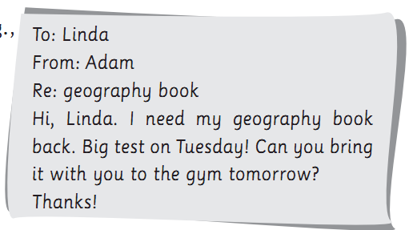
A. Adam has a geography test on Tuesday
B. Linda wants to study at the gym
C. Adam wants to borrow Linda’s book
2.
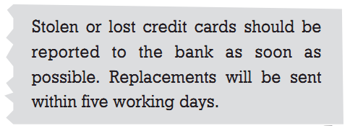
A. New cards are available at the bank
B. Your new card will be mailed within five days
C. You must inform the bank to get a new card
3.
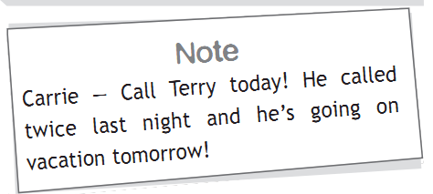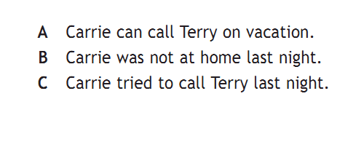
4.
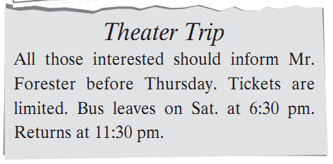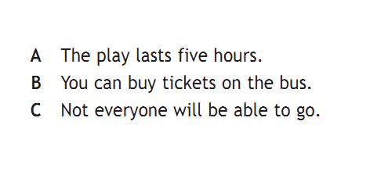
5.
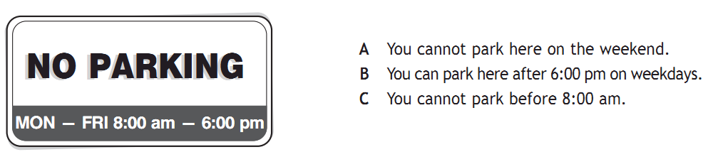

VII. Rearrangement:
1/ affects / The / we /food / eat / our /whole life. /
__________________________________________________________________________________
2/ We / to / need to/ exercise / and stay / fit / keep / and/ healthy./
__________________________________________________________________________________

3/ wash / We / vegetables / and/ should / and fruits / carefully./
__________________________________________________________________________________
4/ is / Bird flu / a / disease. / dangerous / very /
__________________________________________________________________________________

VIII. Read the passage carefully, then write True (T) or False(F)
Yesterday, Hoa and her aunt went to the market. They wanted to buy some meat, vegetables and fruit for dinner. First, they went to the meat stall. There was a good selection on the stall: chicken, pork and beef. Hoa doesn’t pork and her aunt doesn’t either, so they bought some beef.
Next, they went to the vegetable stall. They bought some spinach and cucumbers. Hoa likes them, and so does her aunt. They are her aunt’s favorite vegetables. Finally, Hoa and her aunt stopped at a fruit stall. They wanted a papaya and a pineapple, but they weren’t ripe yet. Therefore, they bought some oranges instead.
1. _____Hoa and her aunt wanted to buy some chicken.
2. _____They went to the market two days ago.
3. _____Papaya and pineapple were ripe.
4. _____Spinach and cucumber are their favorite vegetables.
5. _____There was not beef at the stall.
6. _____They bought some oranges.

IX. Word form:
- (Moderate)………… is very important.
- Vegetables often have (dirt)………… from the farm on them.
- You must wash the vegetables (careful)………….
- She never touches (healthy) food………….
- We must remember to eat (sensible)………….
- We shouldn’t eat much (fat)………… food and sugar.

UNIT 13
I. Multiple choice:
1. They went to the supermarket and _______ some material yesterday. (to buy/ buy / buying/ bought)
2. Don’t forget to wash your ____________ before meals. (feet / hands / teeth / face)
3. The cavity in his tooth was small and wasn’t very ___________( serve / heavy / serious / gave)
4. The nurse told Hoa to return to the __________ -room . (waiting / bath / living / class)
5 . The dentist looks after people ‘s ______________________(hands/ feet/ mouth/ teeth)
6. _________? - 40 kilos.
(What’s your weigh?/ How tall are you?/ How heavy are you?/ What’s your height?)
7. We call it the common cold because every year millions of people _____________it.
(catches / catch / relieve / not relieve)
8. A balanced diet is good ____________ our health. (of/ for/ on/ at)
9. She is very thirsty, and ____________ I(so am / am too / is, too / so do)
10. Minh _________ to the USA next week. (won’t go / doesn’t go / not is going / didn’t go)
11. Walking is a fun , easy and inexpensive __________ (action / activity / act/ inventor)
12. My father is a ____________ driver. He drives his car safely. (careless/ bad/ badly/ careful)
13. We can learn more about the undersea world ________ his invention. (on account of / because of / due to / thanks to)
14. It is difficult __________ this exercise. (doing/ to do/ does/ do)
15. She sings ____( beautiful / nice/ lovely/ beautifully)

II. Put the verb in the correct form :
- Yesterday, John ( tell ) __________________ his story to me.
- What ____________ your father ( do ) _________________ In this morning ?
- Her family ( live ) __________________ In Hanoi in 1990.
- Can you help me ( find ) ____________________my lost books now ?
- Does she want ( be ) ____________________ a singer someday ?
- Our class is interesting in ( read ) __________________ comics.
- Could you please ( tell ) __________________ that story ?
- Remember ( think ) __________________ carefully before saying.
III. Gap filling:
like – don’t – means – life – without - amount – anything – cereals – enjoy - diet
The food we eat affects our whole (1)_____________ .We should have a balanced (2)____________.
We should eat a moderate (3)________________ of fatty food and sugar, some body – building foods (4)_____________ meat and dairy products, plenty of (5)_______________ , fruit and vegetables. A balanced diet (6)______________ we eat a variety of food (7)________________ eating too much of (8)______________. Eat the food we (9)____________ but don’t have too much. (10)_____________ forget about exercise either !

IV. Sentence transformation
- He is a skillful volleyball player.
→ He ___________________________________________________________________________
- Minh is a careful cyclist
→ Minh _________________________________________________________________________
- He plays soccer well.
→ He ____________________________________________________________________________
4. She runs quickly.
→ She ___________________________________________________________________________
5. They swim very fast.
→ They _________________________________________________________________________
6. Nam is a good student.
→ Nam __________________________________________________________________________
7. Mai and Xuan drive carefully.
→ Mai and Xuan __________________________________________________________________
8. Mr Ba is a hard worker.
→ Mr Ba __________________________________________________________________________
9. My father speaks English well.
→ My father ______________________________________________________________________
10. I play tennis badly.
→ I ______________________________________________________________________________

V. Read the passage carefully, then write True (T) or False (F)
We know that the food we eat affects our whole life, so we must remember to eat sensibly. We should have a balanced diet. What does a “balanced diet” means? It means you eat a variety of foods without eating too much of anything. Moderation is very important . Eat the food you enjoy, but don’t have too much . And do exercises everyday this will help you stay fit and healthy.
- _____The food doesn’t affects to our life.
- _____All of us have a balanced diet.
- _____We can eat the food what we like and we don’t care the balanced diet.
- _____Moderation isn’t important.
- _____Do exercises and eat sensibly will help us keep feet and stay healthy.

VI. Word form
- Last year, Mr. Hoang drove very _____________. (CAREFULLY)
- Lan always cycles _____________to school. (QUICKLY)
- My brother plays badminton_____________. (BADLY)
- Mrs. Nga’s son always gets up _____________. (EARLY)
- Nhung’s brother always comes home _____________. (QUIETLY)
- This is very _____________football match. (BORING)
- It’s very _____________to swim there. (SAFE)
- Was Linh _____________at the tennis game last Saturday ? (PRESENT)
- It’s _____________for Trang to lean how to cycle. (EASY)
- The match was between two _____________teams. (AMATEUR)

UNIT 14
I. Multiple choice
- My neighbor _______ the dress for me. ( does/ did / make / made)
- What is her _______ ? ( kilos / heavy/ weight / high)
- Take care of your _______ . ( tooth/ tooths/ teeth/ teeths)
- How _______ did you stay in Ha Noi? ( far / tall/ deep / long)
- You should learn your lesson _______ . (careful / carefully/ careless/ carelessly)
- What are the_______ of the common cold? (symptoms / calls / diseases /catches)
- She _______ to clean her room. (ought / should/ must/ can)
- _______ do you play tennis with? ( What/ When/ How/ Who)
- She fells _______ . ( worried/ worry/ worries/ worrying)
- Is she a _______ jogger? (slow/ slowly/ well/ quickly)
- You must _______ back by seven o’clock. (to be/ be/ are/ being)
- I need a good pair of paddles to play_______ . (tennis/ badminton/ table tennis/ baseball)
- Jogging makes us_______ . (healthy / health / good health / healthful )
- He runs very _______ . (quick / quick ly/ fastly/ slow)
- I don’t want much sugar in my coffee. Just ____, please. ( few/ little/ a little/ a few)

II. Transformation sentence
- Mai forgot to do the homework and I did , too.
→ Mai didn’t_______________________________________________________________________
- She is a good singer.
→She sings_________________________________________________________________________
- How heavy is your brother?
→What____________________________________________________________________________
- She must do this homework before she goes to bed.
→She has __________________________________________________________________________
5. She’s a careful driver.
→ She ____________________________________________________________________________

III. Gap-filling
Members – popular – programs – artists – through
Pop - folk music – part – audience - latest
There are many popular (1) _________________on TV. For example, (2) ________________music is for a broad 3) ___________________, especially teenagers. They both like to listen to the (4) _______________ songs and see the shows of their favorite (5) ______________________
Contests are also very (6) ___________________TV programs. There are contests of knowledge, (7) _________________, games, sports and so on. Students, workers or family (8) ________________ can take (9) _____________________in these contests. TV viewers can join in and answer questions (10) ____________________telephone or by mail.

IV. Rearrangement:
1. Children / outdoor activities / take part / should / in / their friends. /with /
__________________________________________________________________________________
2. use / Many schools / videos / a / as / teaching aid. /
__________________________________________________________________________________
3/ She / finish / must / homework / this / before / to bed / she / goes
__________________________________________________________________________________
4/ many / are / There / game shows / nowadays. / TV / on /
__________________________________________________________________________________
5/ is / player. / a / good / soccer / He/
__________________________________________________________________________________
6/ / is / activity. / Walking / and easy / a / fun /
__________________________________________________________________________________
7/ world’s surface / water. / is / Most of / the /
__________________________________________________________________________________
8/ should / listen to / lifeguards / You / carefully. / the pool /
__________________________________________________________________________________V. Write True or False for the statements about the passage :
Nowadays, we know how important television is for our knowledge about our environment or the world. TV brings us many interesting things: music, entertainment, sports, especially news and documents around the world. The viewers only stay at home and enjoy every program they like. TV is one of the cheapest means of communication.
However, we cannot deny that it also has some negative effects, especially for children, because many movies as shown on TV contained violence, crime and other things which young children or certain people get influence from them.
1. _______ Television is important in our life.
- _______ TV is the cheapest means of communication.
- _______ People can stay at home and enjoy every program they like.
- _______ TV brings us everything about the world.
- _______ TV has its own advantages and disadvantages.
- _______ Children can be influenced by violence, crime and other bad things from watching TV

UNIT 15
I. Multiple choice:
- Every day, I get up early to _______ morning exercises. (do / take / make / play)
- What was wrong _______ you? (to / with/ about/ for)
- Fresh fruit and vegetables are good _______ you. (for/ at/ of/ on)
- I _______ a few letters to my pen pal yesterday. (writes/ write/ to write/ wrote)
- The dentist smiled _______ me and told me not to worry. (at/ to/ with/ in)
- Pop music is the short form of “ _________ music”. (popular / unpopular / popularly / popularity)
- _______ are you talking to? – I’m talking to my friend, Liz . (Where/ Who/ When/ What)
- The bananas aren’t ripe. _______ are those bananas. (Either / So/ Also/ Neither)
- Only few students can _______ English fluently. (speaking / speak / speak to / to speak)
- Blue is my _______ color. (beautiful / favorite / interesting / like)
11. She soon got ____to the busy city traffic. (use/ uses/ using/used)
12. His brother didn’t come to the party last night , and ______________
(Either didn’t he / Either did he / Neither didn’t he / He didn’t either)
13. Fish is my favorite and _______ is beef. (either/ to/ neither/ so)
14. Liz went to the doctor because she _______ sick. (is / are/ was/ were)
15. She went out without _______ anything. (say/ says/ saying/ to say)

II. Give the correct form of the verbs
1. Liz and her parents (go) _____________________ to Hue last week. They (visit) ______________ a lot of beauty spots there.
2. Hoa (decide) ________________ (make) _________________ a skirt yesterday and now she (wear) ________________ it.
3. Ba (be) ______________ 12 years old next Sunday. He (know) _________________ how to take good care of himself.
4. Minh has a toothache because he never (brush) ______________ his teeth. He (go) _____________ to the dentist tomorrow.
5. That evening, Mai’s mother (cook) ______________ rice and (boil) __________________ spinach. Mai (help) ____________________ her to set the table.

III. Gap filling :
Living room – their _ with – watched – had – famous
much – popular – programs – both - more - own
Thirty years ago in Viet Nam, very few people (1) _______________ TV sets. These TV owners were very (2)_______________ .After dinner, their neighbors gathered (3) _______________ inside and outside (4)________________houses. Some watched through the windows.
All evening, they sat and (5) _________________ the black and white programs. The older people might sleep a little and the children might play(6) ________________ their friends, but no one went home until the (7) _____________ finished.
Times have changed. Today, many families have a TV set. People sit in their (8)___________
and watch TV. Life is (9)_________________comfortable now, but many neighbors don’t spend (10)
________________ time together any more.
IV. Word form:
- The …………… of the video games become very rich. (invent)
- Videos are …………… things to have in the classroom. (use)
- Many school use videos as a …………… aid. (teach)
- Children shouldn’t go to the …………… center often. (amuse)
- There was an armed …………… in that store yesterday morning. (rob)
- You must be …………… when you cross the street. (care)
- Coffee is …………… in a mild way. (addict)
- Videos are very useful in …………… (educate)

V. Transformation sentences:
1. I like beef and my sister does, too.
→ I _______________________________________________________________________________
2. How tall is she?
→ What ___________________________________________________________________________
3. What was Peter’s height last year?
→How ___________________________________________________________________________
4. How thick is that novel?
→What __________________________________________________________________________
5. She cycles safely.
→ She is __________________________________________________________________________
6. Let’s see a detective film.
→ What about ______________________________________________________________________
7. Children like picture books very much.
→ Children are very _________________________________________________________________
8. My mother likes walking better than cycling.
→My mother prefers _________________________________________________________________
9. Why don’t we go to the movies this weekend?
→ What about ______________________________________________________________________
- They like to travel to Nha Trang on their vacation.
→ They enjoy ______________________________________________________________________

VI. Rearrangement:
1. Only / students / few / speak / can / fluently / English/.
__________________________________________________________________________________
2. My / busy / parents / are / now / very / work / at/.
__________________________________________________________________________________
3/ play / should not / children / video games / much /too /.
__________________________________________________________________________________
4/ favorite / What / your / is / on / game show / TV /?
__________________________________________________________________________________

VII. Write True or False for the statements about the passage
Videos take an important part in our daily life. It not only brings us a wide variety of amusements but also helps us a lot in business, in education or in the music industry. In fact, most banks and stores nowadays have video cameras to protect their premises. When there is a robbery, the police can study the video to identify the robbers and arrest them more quickly. Videos are also very useful in education. Many schools use them as a teaching aid. You can, for instance, take a university course at home with the help of a VCR (video cassette recorder ). In addition, videos are indispensable in the music industry. You can now buy VCDs (video compact discs ) in many countries all over the world. They play music and show video images at the same time.
- _________Videos take an unimportant part in our life.
- _________They are only useful for amusements.
- _________Most banks and stores have video cameras to protect their premises.
- _________Many schools use videos as a teaching aids
- _________Videos aren’t necessary in the music industry.
- _________VCR stands for video cassette recorder.

UNIT 16
I. Multiple choice :
1. Most of Vietnamese people are very __________ . (famous / important / friendly / comfortable)
2. Peter __________ Xuan Huong Lake 3 days ago. (visit/ visited/ visits/ will visit)
3. Susan didn’t go to school yesterday because she __________ sick . (is/ are/ was/ were)
4. What’ s the matter, Lan ? I have a / an ___________( appointment / toothache / job / homework)
5. Do you know that video games may be ________ ? (addicting / addiction / addictive / additional)
6. They enjoy ________ pictures. (to draw / draw / drawing / draws)
7. Next year, my sister ________ a teacher. ( will / is/ will be/ was)
8. Are you scared ________ crossing the busy streets ? (about / of/ at/ for)
9. I hate durian. ___________ does she . (So/ Either/ Too/ Neither)
10. Who often takes part ____________ the WTS day ? (on/ in/ to/ of)
11. Walking is a / an ____________ activity. (expensive / dangerous / inexpensive /)
12. You should listen to the pool lifeguards_________. (care / careful/ carefully/careless)
13. She plays badminton skillfully. She is a ______ badminton player. (skillfully / skill/ skillful/ skills)
14. Children usually enjoy ___________ cartoons . (to watch/ watch/ watching/ watched)
15. ____ the nurse _____ you yesterday ? (Did- measure/ Do- measure/ Did - measure/ Will - measure)
16. I prefer detective stories ________ historical novels. ( to/ than/ more/ less)
17. Every year, millions of people catch the ________. (headache / common cold / flu/ stomachache)
18. How ________ are you? I’ m 1,5 meters( long/ tall/ old/ heavy)
19. We should have a ________ check up every six months. (medicine / medical / medium/ stadium)
20. My father is a ________ football player. (skill/ skilled/ skillfully/ skillful)

II. FILL IN THE BLANKS WITH THE SUITABLE WORDS IN THE BOX :
be – very – arcades – home – of – time – or – these – to – inventors – rich
Millions (1) ____________ young people play video games. Some play them at (2)_______________
others play them in the arcades. The inventors of the games become (3) _____________ rich. Some of the inventors are as young as 14 (4) _____________ 15.
(5) _____________ games are good fun, but players must (6) _____________ careful. They should not spend much (7)______________ on their own because they like (8)___________ play video games very much.

III. Transformation:
- How heavy are you?
→ What _______________________________________________________________________
- My father likes walking better than cycling.
→My father ____________________________________________________________________
- Let’s play table tennis.
→ What about __________________________________________________________________
- They like hot weather better than cold weather.
→ They prefer __________________________________________________________________
- Minh hates the sound of the drill, and so do I
→ (neither) Minh doesn’t __________________________________________________________

IV. Rearrangement:
1. should not / Teenagers / spend / on / money / too much. / games /
__________________________________________________________________________________
2. My parents / busy / are / now. / very / work / at/
__________________________________________________________________________________
3. are /Video cameras / important / very / police. / for
__________________________________________________________________________________
4. to watching / prefers / books / TV. / My brother / reading/
____________________________________________________________________________
5. your daughter / best? / kinds / does / like / What / TV program / of/
____________________________________________________________________________
6. showing / local cinema / is / horror film / the / a / There / next week. / at/
____________________________________________________________________________

V. Word form:
1. Richard Gere is a famous American ...................... . (act)
2. Thanks for your .................... over the past few weeks. (hospitable)
3. South – East Asia has many .................... . (attract)
4. You can dive and admire ........................ corals and fish. (color)
5. Most teenagers don't like ........................ music. (tradition)
6. The country depends on ..................... for much of its income. (tour)
7. Dien Bien Phu is an important ...................... center. (trade)
8. The dishwasher is a wonderful ...................... . (invent)

MULTIPLE CHOICE
- They had to fill ________their medical records.
A. down B. at C. in D. on
- What was wrong ________you ?
A. to B. with C. about D. for
- Yesterday they had a ________check up.
A. medical B. medicines C. medicine D. medically
- ________is a shop where you can buy medicines .
A. Bakery B. Toy store C. Drug store D. bookstore
- She is 145 centimeters ________
A. tall B. heavy C. old D. high
- I need ________your height.
A. measuring B. to measure C. measure D. DA&B
- How ________is Nga ? – She is 36 kilos.
A. high B. weight C. heavy D. much
- She doesn’t like pork, and ________does her uncle.
A. either B. so C. neither D. too
- My mother didn’t wash it but I ________.
A. did B. didn’t C. do D. was
10. This river is very _____________ for the swimmers.
A. danger B. dangeress C. dangerously D. dangerous
11. Don’t forget to wash your ________ before meals.
A. feet | B. hands | C. teeth | D. legs
12. My aunt tells us a lot ________ you.
A. of | B. about | C. at | D. on
- Wash vegetables and fruit before ____________
A. cooking and eating | B. to cook and to eat | C. cook and eat | D. cooking and eat
- __________ do you brush your teeth? – Twice a day.
A. How much | B. How often | C. How far | D. How long
- What’s _____________ matter? – I have a toothache.
A. a | B. an | C. the | D. some
- What do you do _____ yourself clean ?
A. keep | B. keeping | C. to keep | D. B&C
- I know how to take care _______ myself.
A. of | B. about | C. in | D. for
- The dentist _______ a cavity in my tooth.
A. filled | B. made | C. stopped | D. broke
- ________ do you take morning exercise? – Because it’s good for my health.
A. what | B. why | C. when | D. where
20. We can learn more about the oceans_______________ his invention.
A. thank for B. thank to C. thanks for D. thanks to
21. Hoa filled in her medical ________________________________.
A. check up B. record C. directory D. book
22. Are there any good movies ______________ at the moment?
A. in B. on C. up D of
23. We can learn more about the undersea world ____________ his invention.
A. account of B. because of C. thanks to D due to
24. She __________ the beef into thin strips
A. made B. sliced C. heated D. did
25. Yesterday, I ______________ sick so I didn’t go to the training course.
A. was B. to be C. were D wasn’t
26. My mother didn’t wash it but I ________.
A. did B. didn’t C. Do D was
27. _____________is a shop where you can buy medicines and a lot of other things.
A. Bakery B. Toy store C. Shoe store D. Drugstore
28. You shouldn’t eat too much candy ______________ it’s not good for your teeth.
A. because B. so C. although D. but
29. I’m glad __________ you’re feeling better.
A. hear B. to hear C. hearing D. heard
30. I don’t like carrots and peas. Do you like them? - ________________________.
A. I don’t like tomatoes, either. B. No, neither do I.
C. Yes, I like them, too. D. So do I.
31. Last night we didn’t watch the film on TV because it was ______.
A. bore B. boring C. bored D. boredom
32. He ________ good marks at Math last week
A. got B. gets C. get D. getting
33. My brother cycles________
A. slower B. good C. slowly D. slow
34. How ___________ is the blue hat? It's 50,000 dong
A. much B. many C. old D. far
35. What about ___________to school by bike every morning?
A. go B. went C. going D. goes
36. A lot of people love football. ________.
A. So am I B. Neither do I C. I am too D. So do I
37. I’d like________ cartoons on television.
A. watching B. to watch C. watch D. to watching
38. You ought ________your homework before watching TV
A. finish B. finishing C. finished D. to finish
39. We were worried _________ our examinations.
A. at B. about C. of D. for
40. I need _______ vegetables for dinner.
A. some B. many C. any D. little
41. Life in the city is quite _________ from life in the country.
A. different B. quiet C. noisy D. boring
42. Don’t spend too __________ time and money in the arcade.
A. much B. many C. a lot D. some
43. She doesn’t like pork, and __________ does her uncle.
A. so B. too C. either D. neither
44. The doctor thinks all children _______take part in outdoor activities with their friends.
A. should B. might C. must D. can
45. She is a ___________ basketball player.
A. skillfully B. skill C. skillful D. skilling
46. He ________ his job 2 years ago.
A. starts B. starting C. will start D. started
47. A balanced diet is good_______ your health.
A. to B. with C. in D. for
48. I am going to the ________ center.
A. amuse B. amusing C. amusement D. amused
49. _____ is a person who makes or thinks of something new.
A. Cyclist B. Dentist C. Inventor D. Police
50. I would like ________ you about my family.
A. tell B. telling C. told D. to tell
51. Long was absent ______ class yesterday.
A. off B. on C. away D. from
52. You should eat well, do exercise ______ fit and healthy.
A. to show B. to keep C. to be D. to clean
53. My mother went to the meat stall to buy some ______
A. fruit B. vegetables C. chicken D. peas
54. She hates fish, and ______ do I .
A. so B. too C. either D. neither
55. We should use ______ oil in your food.
A. more B. few C. fewer D. a little
56. In ______ amounts, sugar is good for our health.
A. moderation B. moderate C. moderated D. moderating
57. Jacques Cousteau was a ______ scientist.
A. American B. French C. Vietnamese D. Spanish
58. What are the _____ of the common cold?
A. diseases B. medicines C. symptoms D. prices
59. What about ______ out for dinner?
A. going B. to go C. to going D. go
60. You can buy pineapples and bananas at the ______ stall.
A. meat B. vegetables C. food D. fruit
61. She looks tired. What’s the_______________ with her?
A. wrong B. happen C. matter D. thing
62. My friend’s brother is a_________, but he can’t have his teeth filled by himself
A. dentist B. hairdresser C. dressmaker D. farmer
63. Trang wasn’t late for school yesterday and____________.
A. neither were we B. we were either C. So were we D we were, too
64. These medicines can make you ______________ better.
A. feels B. feeling C.to feel D. feel

65. What’s her_______________? Thirty kilos
A. height B. heavy C. weight D. weigh
66. I didn’t go to school yesterday because I______________ a stomachache.
A. took B. had C. got D. was
67. This river is very________________ for the swimmers.
A. danger B. dangerous C. dangerously D. more dangerous
68. Miss Lan prefers reading books________________ watching TV.
A. more than B. better than C.to D. than
69. We should have a medical______________ every six months.
A. record B. check-up C. treatment D. problem
70. “Would you like to play tennis, Lan?” _ “_______________”
A. I’d love to, but I can’t B. No, I wouldn’t
C. Yes, I would D. Good idea
71. Tim feels sick because he ate too ______________candy last night.
A. much B. a lot of C. more D. many
72. Hoa doesn’t like pork, and __________ does her aunt.
A. either B.so C. neither D. too
73. What was your _________________ last year? – 50 kilos
A. weighs B. weight C. heavy D. weighed
74. My Dad prefers going for a walk ________________ watching TV.
A. than B. more than C.to D. better
75. Minh had an _________________ with the dentist, but he’s afraid.
A. appointment B. appointed C. appointing D. appointments
76. The teacher smiled ______________ the kids and said “hello”.
A.to B. for C. with D.at
77. Mr Tan ________________ Math in a small school many years ago.
A. taught B. is teaching C. teaches D. teach
78. Hoa learned ________________ a sewing machine last week.
A. how use B. how using C. how to use D. how to uses
79. How __________________ is the tower? - 120 meters
A. heigh B. height C. tall D. high
80. Eating a lot of vegetables is very good for our _____________________.
A. healthy B. health C. healthily D. unhealthily
81. The students will have a _____________ check-up this morning.
A. medicine B. medical C. medically D. meditation
82. I hope you can take care of _____________ at school, Michael.
A. yourself B. myself C. herself D. himself
83. Hoa: What ___________ the matter with you, Mai? Mai: I had a backache.
A. is B. were C. was D. are
84. Mrs. Huong has an appointment ____________ the doctor today.
A. by B. at C. in D. with
85. People can learn more about the deep sea __________ Cousteau’s invention.
A. thanks for B. thanks to C. thank you D. thanks
86. Last week, the dentist filled a ____________ in my tooth.
A. activity B. gravity C. cavity D. toothache
87. Mr. Tucker prefers eating in restaurant __________ cooking at home.
A. than B. for C. to D. in
88. Try not to _____________ to brush your teeth twice a day.
A. forget B. want C. decide D. remember
89. Where ___________ you and your brother yesterday?
A. is B. are C. was D. were
90. I’d like ____________ and watch this film with my family.
A. coming B. to come C. come D. came

